Acceptance Testing
UAT Execution & Report Submission

Date | 09 November 2022
Team ID | PNT2022TMID17578
Project Name | Project - A Gesture Based Tool For Steril Browsing of Radiology Images
Maximum Marks | 4 Marks

Purpose of Document
The purpose of this document is to briefly explain the test coverage and open issues of the [ProductName] project at the time of the release to User Acceptance Testing (UAT).

Defect Analysis
This report shows the number of resolved or closed bugs at each severity level, and how
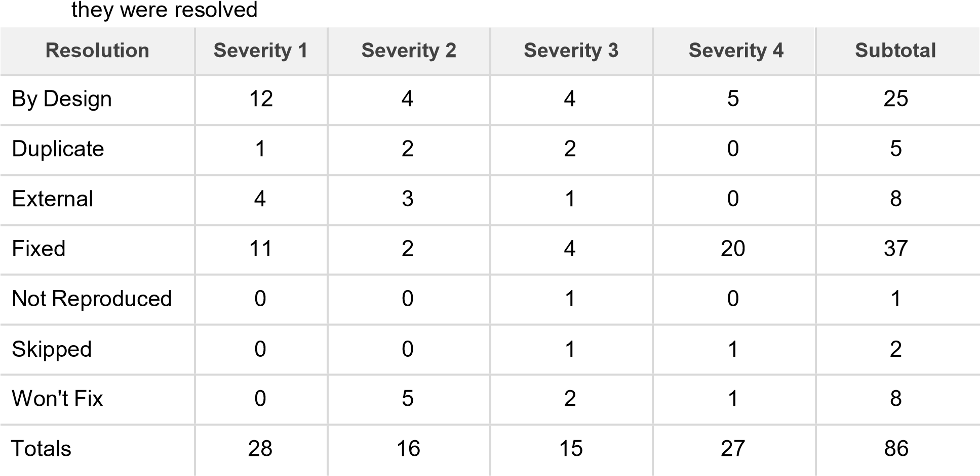

Test Case Analysis
This report shows the number of test cases that have passed, failed, and untested
Section | Total Cases | Not Tested | Fail | Pass
Print Engine | 7 | 0 | 0 | 7
Client Application | 51 | 0 | 0 | 51
Security | 2 | 0 | 0 | 2

Outsource

Shipping

3

0

0

3

Exception

Reporting

9

0

0

9

Final

Report

Output

4

0

0

4

Version

Control

2

0

0

2

